Test on problem 1

1 Chef

; States evaluated: 35

; Cost: 35.011

; Time 0.70

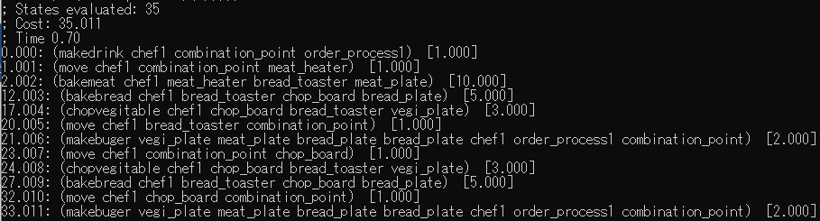

2 Chefs

; States evaluated: 36

; Cost: 14.003

; Time 0.76

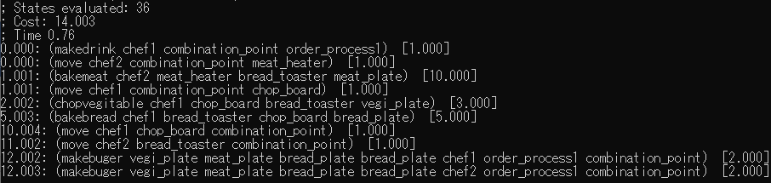

3 Chefs

; States evaluated: 39

; Cost: 13.003

; Time 0.76

